**The sea level rise prediction**

**system**

A graduation project report submission

In partial fulfilment of the requirements for the award of the degree

Bachelor of Science

Submitted by:

1- Mohamed Shaban Eid Kassem 94137

2- Omar Khaled Abd EL-Aziz 94144

3- Moamen Ahmed Mohamed 94245

4- Asmaa Mohamed Kamal 86346

Under the supervision of Supervisor(s):

Dr. Ahmed Fouad

TA. Eng. Mohamed omar

TA. Eng. Mariam Farid

Department of Information Systems - CS

Misr University for Science and Technology - MUST

College of Computers and Artificial Intelligence Technologies - CAIT

June 2023

**ACKNOWLEDGMENT**

We are very grateful to God Almighty who gave us the opportunity, strength, determination and will to achieve our goal that we were striving to achieve. Without his support this would not have been possible. Many people contributed to its production either morally or supplying us with the necessities we needed. We owe our gratitude to all those people who made this message possible and because of them our alumni experience was one we will cherish and remember forever.

Above all, we would like to express our sincere gratitude to our advisor, **Dr. Ahmed Fouad**, for the continuous support of our project study and research, for his patience, motivation, enthusiasm, and immense knowledge. His guidance helped us all the time researching and writing this paper.

We could not have imagined a better advisor and mentor for the study of our project. Besides our advisor, we would like to thank the rest of our research committee: **Eng. Mohamed Omar**, **Eng. Mariam Farid,** whose expertise, understanding, and patience, added considerably to our graduate experience. We appreciate their vast knowledge and skill in many areas, and their assistance in writing reports. Finally, most importantly, none of this would have been possible without the love and patience of our families. Our immediate families to whom this dissertation is dedicated to, has been a constant source of love, concern, support and strength all these years. We would like to express our heart-felt gratitude deep thanks to our families. So, our extended families have aided and encouraged us throughout this endeavor.

**DECLARATION**

I hereby certify that this work, which I now submit for assessment on the programmed of study leading to the award of Bachelor of Science in *(insert title of degree for which registered)* is entirely my own work, that I have exercised reasonable care to ensure that the work is original, and does not to the best of my knowledge breach any law of copyright, and has not been taken from the work of others and to the extent that such work has been cited and acknowledged within the references section of this report.

**Signed:** _____________________________

**Registration No.:** ___________

**Date:** Day, Month Year.

**ABSTRACT**

The rise in global sea levels is a pressing environmental concern with far-reaching implications for coastal communities and ecosystems. In this study, we present a machine learning-based approach for predicting future sea level rise. By leveraging historical sea level data and relevant environmental factors throughout our Sea level dataset, our model aims to provide accurate forecasts and predicting, enabling proactive mitigation and adaptation measures. We employ various regression algorithms, such as linear regression, random forest, decision tree, K-nearest neighbors, lasso regression, and ridge regression, to analyze the complex relationships between sea level and the other contributing factors. Our findings reveal the predictive power of these models and their potential to assist policymakers, urban planners, and coastal communities in making informed decisions to mitigate the adverse effects of rising sea levels.

Contents

**CHAPTER ONE: INTRODUCTION** 8

**1.** **OVERVIEW** 10

**1.1 PROBLEM DEFINITION:** 12

**1.2 SYSTEM OBJECTIVE:** 13

**1.3 MOTIVATION** 13

**1.4 SYSTEM REQUIRMENTS:** 13

**1.4.1 System Functional Requirements** 13

**1.4.2 System Non-Functional Requirements** 14

**CHAPTER TWO: LITERATURE SURVEY AND RELATED** 16

**WORK.** 16

**RELATED WORK** 18

**COMPARATIVE STUDY BETWEEN OUR WORK AND OTHER RELATED WORKS IN THE LITERATURE.** 24

**SYSTEM ARCHITECTURE** 26

**PROJECT TIME PLAN** 27

**CHAPTER THREE: SYSTEM ANALYSIS AND DESIGN** 29

**UML DIAGRAMS** 31

**Context Diagram** 31

**Use Case Diagram** 32

**Sequence Diagram** 33

**Class Diagram** 34

**ERD Diagram** 35

**State Diagram** 36

**Activity Diagram** 37

**SYSTEM FUNCTIONAL REQUIREMENTS** 38

**SYSTEM NON-FUNCTIONAL REQUIREMENTS** 38

**CHAPTER FOUR: PROPOSED SYSTEM** 41

**ALL USED ALGORITHMS** 43

**PROJECT METHODOLOGY** 47

**ALL TOOLS USED** 51

**CHAPTER FIVE: RESULTS AND DISCUSSION** 54

**A.** **ANALYSIS OF THE RESULT** 56

**B.** **DISCUSSION AND COMPARATIVE STUDY WITH YOUR WORK RESULT** 59

**Screenshots of Desktop Application Implementation: -** 60

**C.** **CONCLUSION OF THE RESULTS** 63

**CONCLUSION** 65

**REFERENCES** 66

Table Of Figures

Figure 1: Causes of sea level increase. 11

Figure 2:Area of interest in the harbor of Brest and the city of Landerneau (shown with triangles). 19

Figure 3:Architecture of a Multilayer Perceptron (MLP) with two hidden layers. 19

Figure 4:Location of the study area 20

Figure 5:flow chart for sea level prediction methodology 20

Figure 6:Location of the study area. 22

Figure 7:The flowchart of the developed model 22

Figure 8:Project time plan 27

Figure 9:Context Diagram 31

Figure 10:Use Case Diagram 32

Figure 11:Sequence Diagram for user 33

Figure 12:Class Diagram 34

Figure 13:ERD Diagram 35

Figure 14:State Diagram 36

Figure 15:Activity Diagram 37

Figure 16:Project Methodology 47

Figure 17:linear regression predicted vs true values 56

Figure 18:Random Forest Actual vs predicted 57

Figure 19: Decision Tree Actual vs predicted 57

Figure 20:KNN Actual vs Predicted 58

Figure 21:Lasso Actual vs predicted 58

Figure 22:Ridge Actual vs predicted 58

Figure 23:MSE Graph 59

Figure 24:R2 Graph 59

Figure 25:Desktop Application's Main Screen 60

Figure 26:Desktop Application's Main Screen with Algorithms and uploaded dataset 61

Figure 27:Desktop Application's Show Data Button Screen 61

Figure 28:Desktop Application's Show Stats Button Screen 62

Figure 29:Result applying Linear Regression Algorithm and the right output column 62

Figure 30:Graph of applying linear regression algorithm 63

Table 1: MSE, R2 for all algorithms 59



# **CHAPTER ONE: INTRODUCTION**



## **OVERVIEW**

Climate change represents one of the major global issues to be addressed in the coming years. It can be considered as the “issue of our time”. The Sea level rises for several reasons like heatwaves, heavy rain, fires, coastal flooding, and as temperature increases, ice melts and it contributes in increasing the sea level and those events are happening all over the world and they are increasing not decreasing. The accelerating rise in global sea levels has shown as a critical issue for both human societies and natural ecosystems in our world. This important phenomenon is primarily driven by anthropogenic factors, including greenhouse gas emissions and climate change, which contribute to the thermal expansion of seawater and the melting of polar ice sheets and glaciers. The consequences of sea level rise are far-reaching and encompass a range of challenges, including increased coastal erosion, the submergence of low-lying areas, and heightened vulnerability to extreme weather events and storm surges. To effectively address these multifaceted challenges, it is imperative to have accurate predictions of future sea level rise.

In recent years, machine learning has emerged as a powerful and innovative approach for analyzing complex environmental data and making precise predictions. By harnessing large-scale datasets that encompass historical sea level measurements and relevant environmental variables, machine learning algorithms can uncover intricate patterns, quantify relationships, and generate forecasts with a high degree of accuracy. In this study, we capitalize on the potential of machine learning techniques to develop robust predictive models for sea level rise.

Our approach centers around the utilization of various regression algorithms, such as linear regression, random forest, decision tree, K-nearest neighbors, lasso regression, and ridge regression. By incorporating a diverse set of variables such as temperature, precipitation, humidity, wind speed. we aim to capture the complex dynamics driving sea level changes. Through a comprehensive analysis of these variables, our predictive models can provide valuable insights into future sea level rise scenarios, enabling policymakers, urban planners, and coastal communities to anticipate and plan for the associated impacts.

The primary objective of our research is to contribute to the expanding body of knowledge on sea level rise prediction and facilitate evidence-based decision-making. By leveraging the potential of machine learning models, we seek to enhance the resilience of coastal communities, inform adaptive strategies, and support sustainable development efforts. The insights derived from our machine learning models can serve as a valuable resource for policymakers, guiding them in implementing effective measures to address the challenges posed by rising sea levels. Ultimately, our aim is to contribute to the broader understanding of sea level rise and empower stakeholders to make informed decisions that promote the long-term sustainability and well-being of both human and natural systems in the face of this formidable global issue. And here are the causes of sea level increase as shown in figure1 [1]

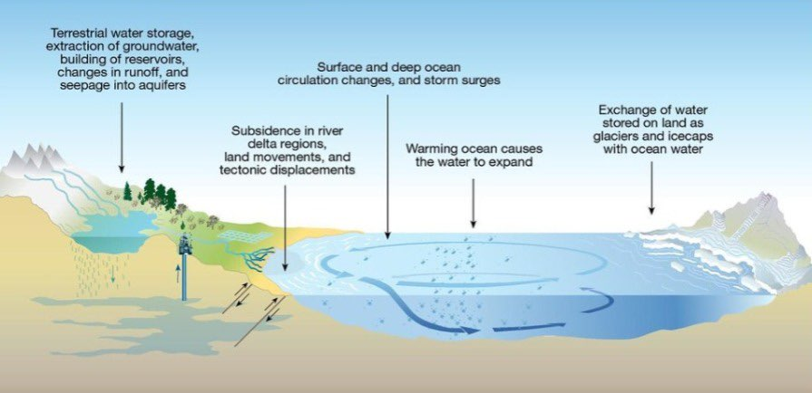

Figure : Causes of sea level increase.

## **1.1 PROBLEM DEFINITION:**

In recent years, the escalating rise in global sea levels has become a matter of great concern due to its significant implications for coastal communities and fragile ecosystems worldwide. This pressing issue has compelled researchers and policymakers to recognize the urgent need for accurate prediction models that can effectively forecast sea level rise and provide valuable insights into its potential impact.

The primary challenge we aim to address in this project is the development of a reliable and precise sea level prediction system. The accelerating sea level rise has multifaceted consequences, including the heightened risks of coastal erosion, the encroachment of seawater into low-lying areas, which are vital for both human populations and ecosystems. These adverse effects can lead to the loss of coastal habitats, displacement of communities, and the degradation of crucial infrastructure, making it essential to implement proactive measures to mitigate the potential impacts.

To effectively tackle these challenges, it is crucial to have access to accurate and trustworthy sea level predictions that can guide decision-makers in formulating appropriate strategies for coastal management, urban planning, and infrastructure development. Such predictions enable policymakers to assess the vulnerability of coastal areas, plan for future scenarios, allocate resources effectively, and implement adaptive measures to minimize the adverse effects of sea level rise.

Moreover, accurate sea level predictions are paramount for coastal communities and inhabitants who need to anticipate and prepare for the potential consequences of rising sea levels. Timely and reliable forecasts empower communities to develop resilience strategies, implement coastal protection measures, and make informed decisions regarding land use, construction practices, and infrastructure development.

In summary, the problem we aim to address in this project is the critical need for accurate sea level predictions to effectively mitigate the challenges posed by the accelerating rise in global sea levels. By developing a robust and reliable sea level prediction system, we can provide stakeholders with the essential information needed to proactively plan for the impacts of sea level rise, protect vulnerable coastal communities and ecosystems, and ensure sustainable development in the face of this formidable challenge.

## **1.2 SYSTEM OBJECTIVE:**

The objective of our system is to develop a machine learning-based sea level prediction system that can provide accurate forecasts of future sea level rise. By leveraging historical sea level data and relevant environmental factors, our system aims to assist policymakers, urban planners, and coastal communities in making informed decisions and implementing proactive measures to mitigate the adverse effects of rising sea levels.

**1.3 MOTIVATION:**

The motivation behind this project stems from the increasing significance of sea level rise as a global environmental concern. Understanding and predicting sea level changes are crucial for adapting to and mitigating the potential impacts on coastal regions. By developing an accurate prediction system, we aim to contribute to the scientific understanding of sea level dynamics and support sustainable development practices.

## **1.4 SYSTEM REQUIRMENTS:**

### **1.4.1 System Functional Requirements**

* Data Collection: The system should be able to collect sea level data from reliable sources.
* Data Preprocessing: The system should preprocess the collected data by handling missing values, outliers, and normalization.
* Algorithm Selection: The system should provide a mechanism to select appropriate machine learning algorithms for sea level prediction.
* Model Training: The system should train the selected algorithms using the preprocessed data to create accurate prediction models.
* Model Evaluation and Validation: The system should evaluate the trained models using appropriate evaluation metrics and validate their performance.
* Exclude Bad Results Algorithms: The system should identify and exclude algorithms that do not meet the desired performance criteria.
* Desktop Application Development: The system should develop a user-friendly desktop application for accessing and interacting with the sea level prediction models.
* User Interaction and Result Analysis: The system should enable users to input query parameters, visualize prediction results, and perform result analysis.

### **1.4.2 System Non-Functional Requirements**

* Performance: The system should be capable of processing large datasets and delivering timely and efficient predictions.
* Accuracy: The system should provide accurate and reliable sea level predictions based on the selected algorithms.
* Usability: The desktop application should have an intuitive and user-friendly interface to facilitate easy interaction and result analysis.
* Scalability: The system should be scalable to handle increasing volumes of data and accommodate future enhancements.
* Reliability: The system should be stable and available for use without frequent interruptions or failures.
* Compatibility: The desktop application should be compatible with common operating systems and environments.
* Maintainability: The system should be designed and implemented in a modular and maintainable manner to facilitate future updates and modifications.



# **CHAPTER TWO: LITERATURE SURVEY AND RELATED**

# **WORK.**



## **RELATED WORK**

1. **Machine learning methods applied to sea level predictions in the upper part of a tidal estuary, Laboratoire de Génie Côtier et Environnement (LGCE), Cerema, Plouzané, France 2021 [2]:**

The research paper titled "Machine learning methods applied to sea level predictions in the upper part of a tidal estuary" conducted by the Laboratoire de Génie Côtier et Environnement (LGCE), Cerema, Plouzané, France in 2021 addresses the challenge of predicting sea level variations in the upper part of an estuary using machine learning algorithms.

The study contributes to the field by exploring an efficient and rapid solution to predicting sea levels in estuaries, which traditionally relied on computationally expensive numerical simulations. By applying multiple regression methods (linear and polynomial regression) and by using an artificial neural network (multilayer perceptron) to three years of sea level observations in the upper part of the Elorn estuary in France, the researchers demonstrate the effectiveness of machine learning algorithms in capturing temporal variations at different time scales.

One of the significant contributions of this research is the improved assessment of inundation events, which were previously based on observations or numerical simulations in the downstream part of the estuary. The machine learning models provide accurate predictions, allowing for better understanding and management of sea level dynamics in the upper estuarine region.

The findings suggest that the selected input variables in their dataset, they used four inputs from other models that considered in relation to tidal and coastal surge effects. including the French tidal coefficient, atmospheric pressure, wind velocity, and river discharge, are sufficient for capturing sea level variations. The study also highlights the limited influence of wind and river discharges on inundation events in the specific area under investigation.

Overall, this research demonstrates the potential of machine learning methods in enhancing the prediction of sea level variations in estuaries. The use of efficient algorithms opens new avenues for understanding and managing the impacts of sea level rise, particularly in coastal regions where accurate predictions are crucial for effective decision-making and adaptation strategies.

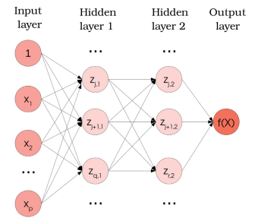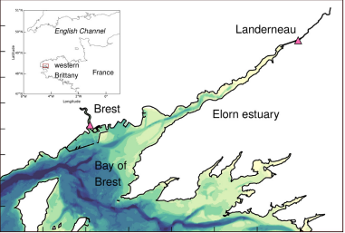

Figure :Area of interest in the harbor of Brest and the city of Landerneau (shown with triangles).

Figure :Architecture of a Multilayer Perceptron (MLP) with two hidden layers.

1. **Sea Level Prediction Using Machine Learning, Department of Civil Engineering, Akdeniz University and Department of Civil Engineering, Antalya Bilim University and Water Energy and Environmental Engineering Research Unit, University of Oulu 2021 [3]:**

the research paper titled "Sea Level Prediction Using Machine Learning" presents a methodology for predicting sea level changes in Antalya Harbor, Turkey. The study explores different input combinations and compares linear-based (MLR) and nonlinear-based (ANFIS) models for sea level prediction.

The researchers established two scenarios (SC1, SC2): SC1, which uses lagged sea level observations only as input, and SC2, which are both lagged sea level and meteorological factor observations. This Cross-correlation analysis was conducted to identify the optimal input combination for each scenario. The performance of the developed models was evaluated using various statistical indicators such as root mean squared error (RMSE), mean absolute error (MAE), and other types indicators.

The results showed that including meteorological factors as input parameters significantly improved the accuracy of the MLR models for short-term sea level predictions. Furthermore, the study concluded that the ANFIS model outperformed the MLR model for sea level prediction, regardless whether the input is SC1 or SC2. So, the ANFIS model performed better in this study.

It is important to note that the research findings are specific to the case study area of Antalya Harbor so this research and algorithms is applicable here but may not be directly applicable to other regions. The paper suggests that further studies could explore additional hydrological processes, such as rainfall and runoff, to enhance the methodology.

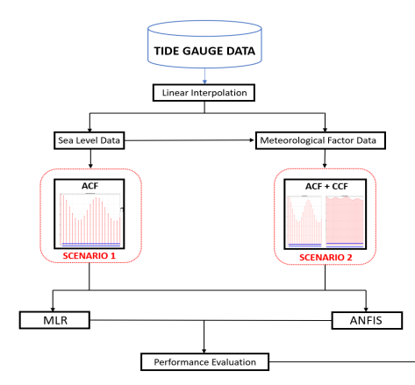Overall, this research paper contributes to the field of sea level prediction by presenting a methodology that combines lagged sea level observations and meteorological factors, and compares the performance of linear and nonlinear models. The findings highlight the importance of considering meteorological factors in sea level prediction models and suggest the superiority of the ANFIS model in this context.



Figure :Location of the study area

Figure :flow chart for sea level prediction methodology

1. **Time-Series Prediction of Sea Level Change in the East Coast of Peninsular Malaysia from the Supervised Learning Approach, Department of Civil Engineering, College of Engineering, Universiti Tenaga Nasional 2020 [4]:**

The research paper titled "Time-Series Prediction of Sea Level Change in the East Coast of Peninsular Malaysia from the Supervised Learning Approach" focuses on analyzing and predicting sea level changes on the east coast of Peninsular Malaysia using a machine learning algorithm called Regression Support Vector Machine (RSVM). The study aims to provide accurate predictions of monthly mean sea level rises in Malaysia by incorporating meteorological parameters in their dataset such as monthly mean sea level, sea surface temperature, rainfall, and mean cloud cover.

The study utilizes a dataset spanning from the period from January 2007 to December 2017.The results demonstrate that the RSVM model accurately predicts sea level rises, as evidenced by high correlation coefficients (R) of 0.861, 0.825, and 0.857 for the Kerteh, Tanjung Sedili, and Tioman Island stations, respectively. The predicted values align closely with historical tide-gauge data, indicating the reliability and potential of the RSVM model as a decision-making tool for predicting monthly mean sea level rises in Malaysia.

In conclusion, the research highlights the efficacy of the proposed RSVM model for simulating sea level changes in the coastal areas of Malaysia. The study outperforms conventional models and emphasizes the importance of selecting appropriate meteorological parameters as inputs to enhance prediction accuracy. The findings have significant implications for assessing the vulnerability of coastal areas, particularly Tioman Island, to sea level changes. Furthermore, the research suggests the potential for applying the RSVM model in other countries and regions to validate its accuracy.

Overall, this research paper contributes to the field of sea level prediction by demonstrating the successful application of the RSVM algorithm in a specific coastal region. The findings provide valuable insights for understanding and managing the impact of sea level changes in Malaysia and offer opportunities for future research to validate and extend the proposed model to other geographical areas.

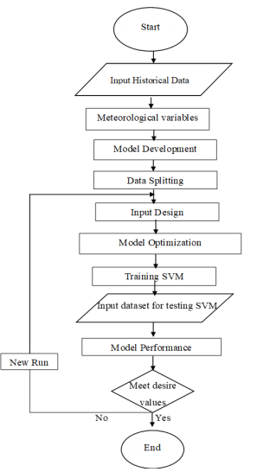

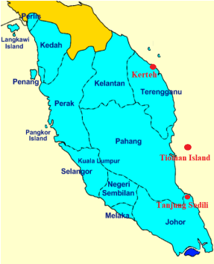

Figure :Location of the study area.

Figure :The flowchart of the developed model

1. **Sea-level rise in the Mediterranean Sea to 2050: Roles of terrestrial ice melt, steric effects and glacial isostatic adjustment, Dipartimento di Scienze di Base e Fondamenti (DiSBeF), Università degli Studi di Urbino "Carlo Bo", Urbino, Italy 2014 [5]:**

The research paper titled "Sea-level rise in the Mediterranean Sea to 2050: Roles of terrestrial ice melt, steric effects, and glacial isostatic adjustment" focuses on assessing the regional pattern of future low-frequency sea-level variations in the Mediterranean Sea. The study combines three components: terrestrial ice melt, glacio-isostatic adjustment (GIA), and steric sea-level changes to provide projections for sea-level rise in the region.

The study utilizes global scenarios for the future mass balance of ice sheets, glaciers, and ice caps to estimate the terrestrial ice melt component. GIA modeling is employed, considering different assumptions about Earth's rheology and the chronology of deglaciation since the Last Glacial Maximum. Steric sea-level changes are derived from published simulations based on regional atmosphere-ocean coupled models. The projections are focused on the period from 2040 to 2050.

The findings suggest that by 2040-2050, the total basin-averaged sea-level rise in the Mediterranean Sea will range from 9.8 to 25.6 cm, depending on the scenarios considered. The terrestrial ice melt component is expected to surpass the steric contribution, although the latter exhibits the strongest regional imprint. The study also indicates that glacial isostatic adjustment will have minor effects on sea-level variations in the region.

In conclusion, the research paper provides valuable insights into the future sea-level changes in the Mediterranean Sea, considering multiple contributing factors. The study highlights the significance of the terrestrial ice melt component and its impact on sea-level rise, as well as the regional variability associated with steric effects and glacial isostatic adjustment. The findings contribute to understanding the local implications of sea-level rise and can be utilized for assessing vulnerability and developing adaptation strategies in coastal areas of the Mediterranean region.

Overall, this research enhances our understanding of the complex dynamics of sea-level rise in the Mediterranean Sea and underscores the importance of considering various factors in projecting future changes. The study's comprehensive approach and its regional focus make it a valuable contribution to the field of sea-level rise research and can inform decision-making processes regarding coastal management and adaptation in the Mediterranean region.

By thoroughly reviewing and summarizing these related works, we aim to contribute to the existing body of knowledge on sea level prediction using machine learning. This literature survey provides us with valuable insights and serves as a basis for our project. In the subsequent sections of this chapter, we will further elaborate on the theoretical aspects of our work, presenting our project description in detail.

## **COMPARATIVE STUDY BETWEEN OUR WORK AND OTHER RELATED WORKS IN THE LITERATURE.**

In this section, we present a comparative study between our work and other related works in the literature that focus on sea level prediction using machine learning techniques. The purpose of this comparison is to highlight the unique contributions and advancements of our work in relation to existing research.

1. **Machine learning methods applied to sea level predictions in the upper part of a tidal estuary, Laboratoire de Génie Côtier et Environnement (LGCE), Cerema, Plouzané, France, 2021:**

While this study concentrates on the upper part of a tidal estuary, our work expands the scope to predict sea level rise on a global scale. By considering global trends and potential impacts, our predictions provide a more comprehensive understanding of sea level rise and its implications beyond specific localities.

1. **Sea Level Prediction Using Machine Learning, Department of Civil Engineering, Akdeniz University, Department of Civil Engineering, Antalya Bilim University, and Water Energy and Environmental Engineering Research Unit, University of Oulu, 2021:**

In comparison to this study, our work goes beyond the utilization of machine learning algorithms for sea level prediction. We incorporate additional factors, such as climate data, environmental parameters, and historical trends, to enhance the accuracy and reliability of our predictions. By considering a wider range of influencing factors, our approach offers a more holistic perspective on sea level rise and its underlying dynamics.

1. **Time-Series Prediction of Sea Level Change in the East Coast of Peninsular Malaysia from the Supervised Learning Approach, Department of Civil Engineering, College of Engineering, Universiti Tenaga Nasional, 2020:**

While this study focuses on sea level changes in the East Coast of Peninsular Malaysia, our work contributes to the field by offering a broader scope. We analyze global sea level rise patterns and their potential implications for various regions. By providing insights into the overall magnitude and impact of sea level rise, our work aids in understanding the global context and developing appropriate mitigation strategies.

1. **Sea-level rise in the Mediterranean Sea to 2050: Roles of terrestrial ice melt, steric effects, and glacial isostatic adjustment, Dipartimento di Scienze di Base e Fondamenti (DiSBeF), Università degli Studi di Urbino "Carlo Bo," Urbino, Italy, 2014:**

Although this study does not directly employ machine learning techniques, it offers valuable insights into the factors influencing sea-level rise in the Mediterranean Sea. In comparison, our work leverages machine learning algorithms to predict sea level rise globally, considering various factors such as climate data and environmental parameters. By incorporating machine learning, we enhance the accuracy and efficiency of our predictions, enabling more informed decision-making and effective mitigation strategies.

Overall, our work distinguishes itself by combining machine learning algorithms with a comprehensive analysis of global sea level rise trends. By considering multiple influencing factors and a broader geographical context, our predictions offer valuable insights into the magnitude and impact of sea level rise on a global scale. This comparative study highlights the unique contributions and advancements of our work in the field of sea level prediction using machine learning techniques.

## **SYSTEM ARCHITECTURE**

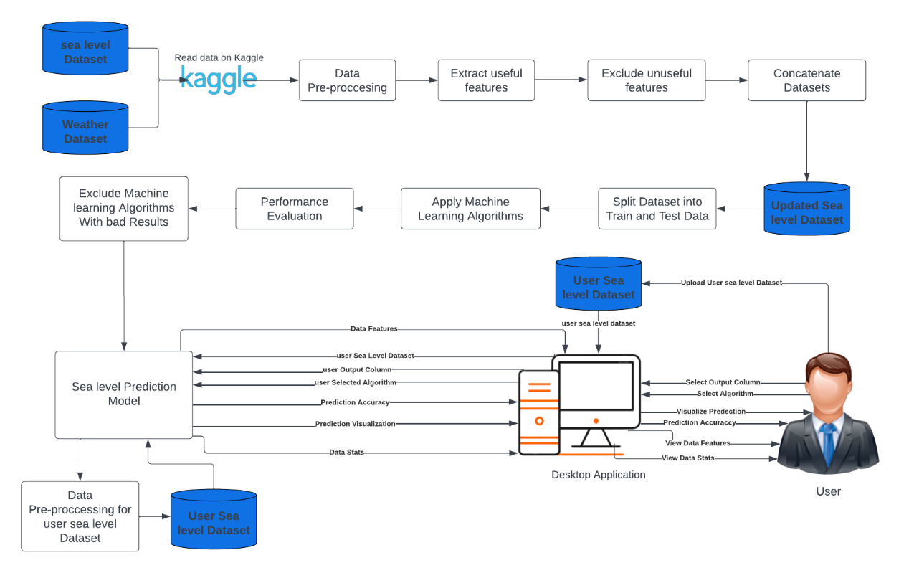The purpose of system architecture activities is to define a comprehensive solution based on principles, concepts, and properties logically related and consistent with each other. The solution architecture has features, properties, and characteristics satisfying, as far as possible, the problem or opportunity expressed by a set of system requirements and life cycle concepts and are implementable through technologies. System Architecture is abstract, conceptualization-oriented, global, and focused to achieve the mission and life cycle concepts of the system. It also focuses on high‐level structure in systems and system elements. It addresses the architectural principles, concepts, properties, and characteristics of the system-of-interest. It may also be applied to more than one system, in some cases forming the common structure, pattern, and set of requirements for classes or families of similar or related systems [6].

Figure2: System Architecture

## **PROJECT TIME PLAN**

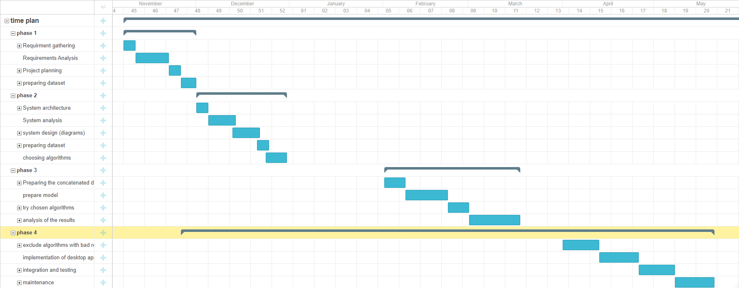

Figure :Project time plan

# 



# **CHAPTER THREE: SYSTEM ANALYSIS AND DESIGN**



## **UML DIAGRAMS**

### **Context Diagram**

The context diagram provides an overview of the system's boundaries and interactions with external entities. and what is the relationship of the system with these external entities.

A context diagram, sometimes called a level 0 data-flow diagram, is drawn in order to define and clarify the boundaries of the software system. It identifies the flows of information between the system and external entities. The entire software system is shown as a single process [7].This diagram helps in understanding the scope of the system and identifying the external entities with which it interacts.

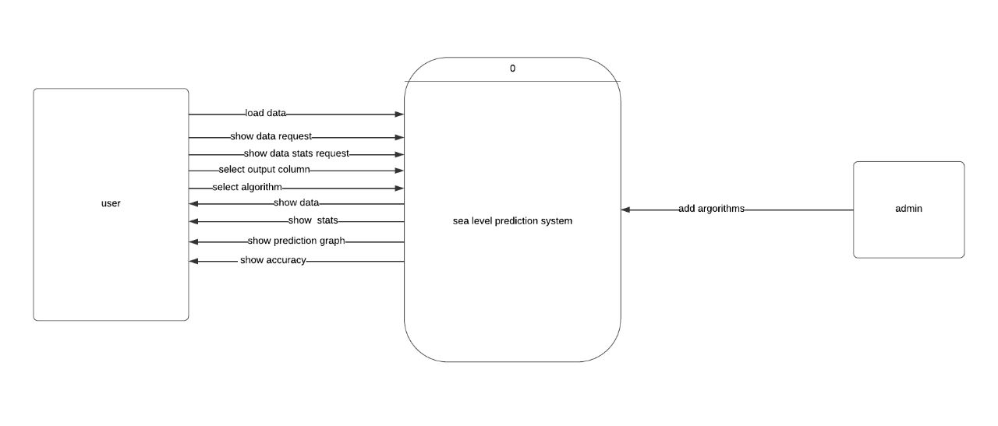

Figure :Context Diagram

### **Use Case Diagram**

The use case diagram depicts the functionalities and interactions between actors (users or external systems) and the system. A use case diagram can summarize the details of your system's users (also known as actors) and their interactions with the system [8].

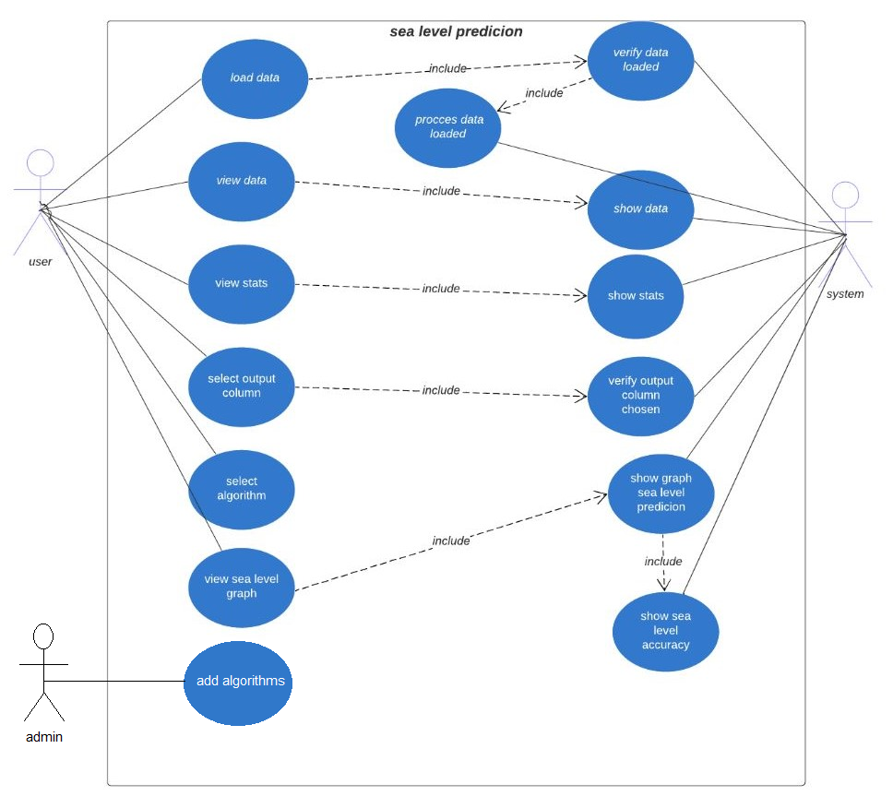

Figure :Use Case Diagram

### **Sequence Diagram**

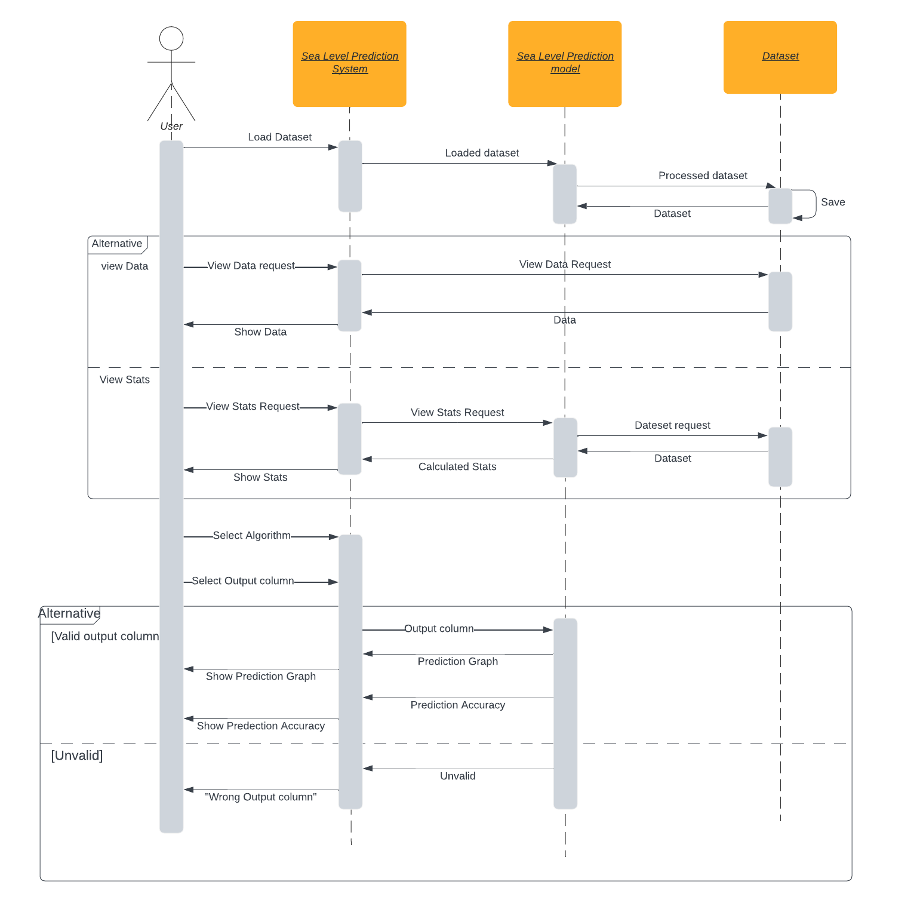The sequence diagram is used primarily to show the interactions between objects in the sequential order that those interactions occur. [9]. It represents the dynamic behavior of a system by showing the order in which messages are exchanged between objects over a specific period of time.

Figure :Sequence Diagram for user

### **Class Diagram**

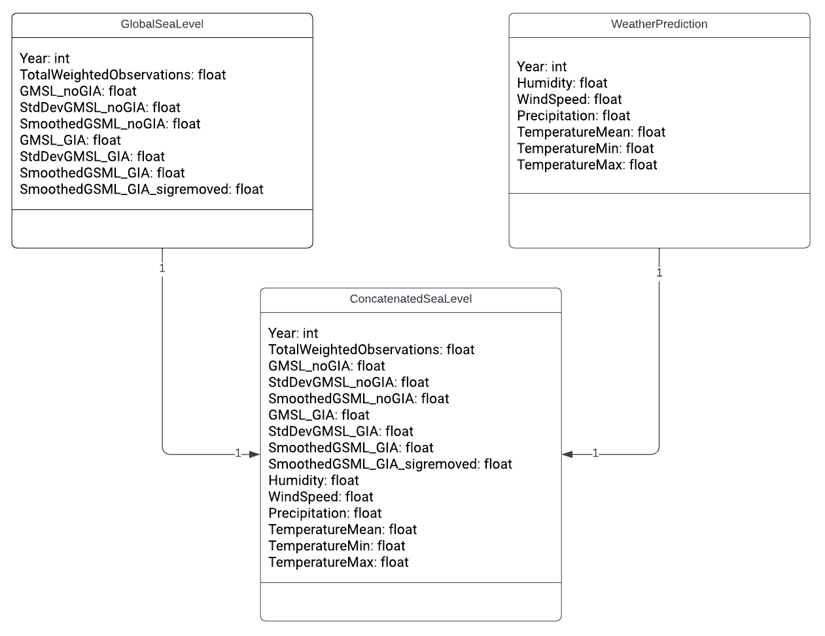The class diagram represents the static structure of the system by illustrating the classes, their attributes, relationships, and methods. It helps in modeling the system's data structure and the relationships between different entities or objects. T The purpose of class diagram is to model the static view of an application. Class diagrams are the only diagrams which can be directly mapped with object-oriented languages and thus widely used at the time of construction [10].

Figure :Class Diagram

### **ERD Diagram**

The Entity Relationship Diagram (ERD) represents the database schema for the system. It illustrates the entities and their attributes, and the relationships between them. This diagram helps in understanding the system's data model.

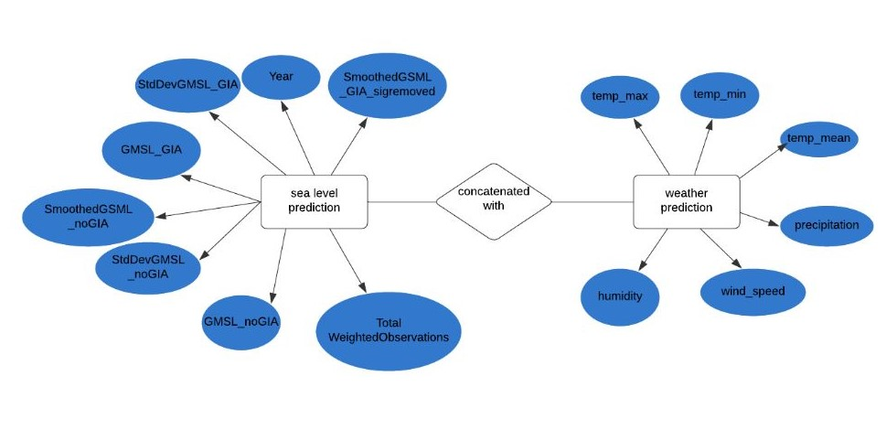

Figure :ERD Diagram

### **State Diagram**

The state diagram depicts the different states that an object or system can go through and the transitions between those states. State chart diagram describes the flow of control from one state to another state. States are defined as a condition in which an object exists, and it changes when some event is triggered [11]. This diagram is useful for understanding the system's dynamic behavior and how it changes its state based on events.

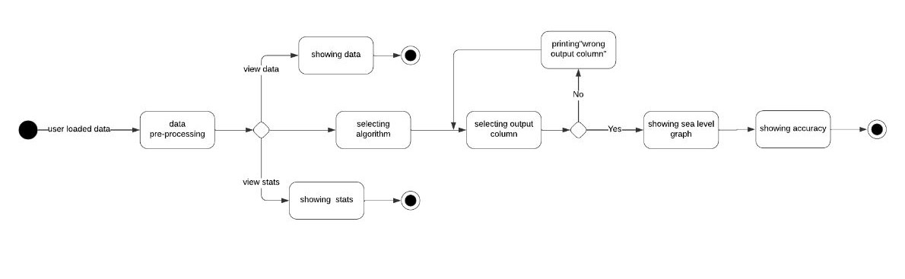

Figure :State Diagram

### **Activity Diagram**

Activity Diagrams describe how activities are coordinated to provide a service which can be at different levels of abstraction [12]. The activity diagram represents the flow of activities or actions within a process or use case. It illustrates the sequence of activities, decision points, and the flow of control between different actions. This diagram helps in understanding the system's workflow and the steps involved in completing a particular process.

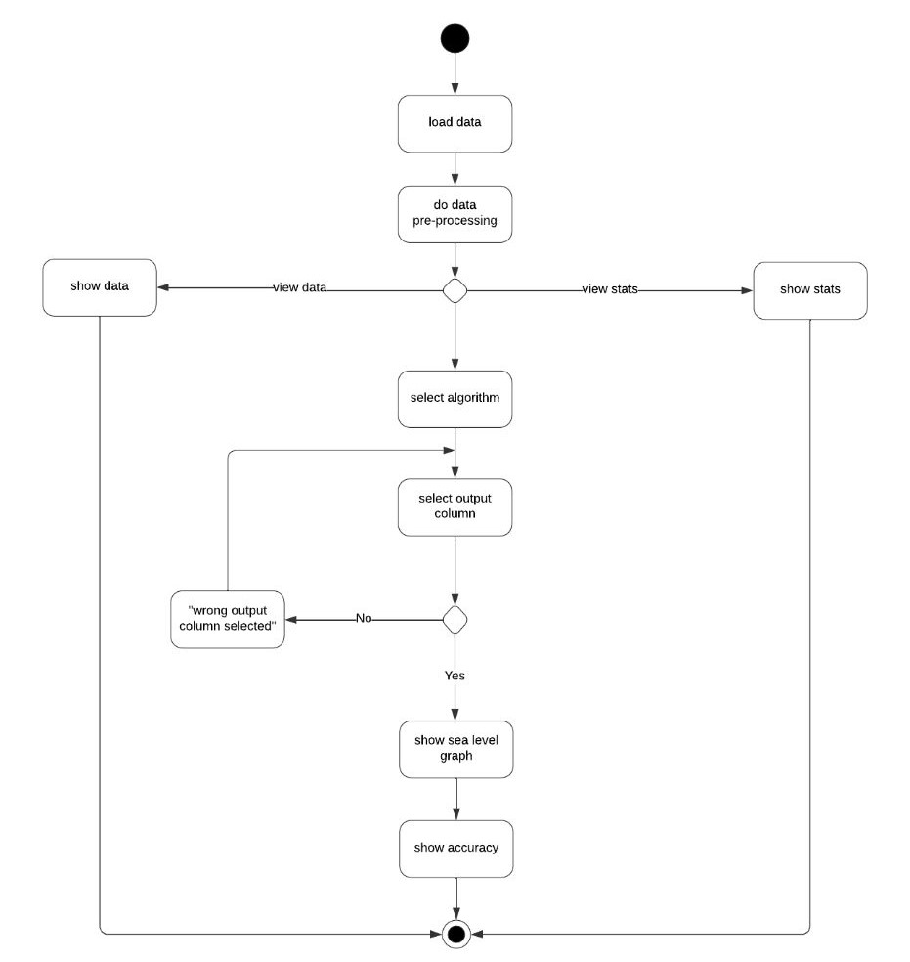

Figure :Activity Diagram

## **SYSTEM FUNCTIONAL REQUIREMENTS**

* Data Collection: The system should be able to collect sea level data from reliable sources.
* Data Preprocessing: The system should preprocess the collected data by handling missing values, outliers, and normalization.
* Algorithm Selection: The system should provide a mechanism to select appropriate machine learning algorithms for sea level prediction.
* Model Training: The system should train the selected algorithms using the preprocessed data to create accurate prediction models.
* Model Evaluation and Validation: The system should evaluate the trained models using appropriate evaluation metrics and validate their performance.
* Exclude Bad Results Algorithms: The system should identify and exclude algorithms that do not meet the desired performance criteria.
* Desktop Application Development: The system should develop a user-friendly desktop application for accessing and interacting with the sea level prediction models.
* User Interaction and Result Analysis: The system should enable users to input query parameters, visualize prediction results, and perform result analysis.

## **SYSTEM NON-FUNCTIONAL REQUIREMENTS**

* Performance: The system should be capable of processing large datasets and delivering timely and efficient predictions.
* Accuracy: The system should provide accurate and reliable sea level predictions based on the selected algorithms.
* Usability: The desktop application should have an intuitive and user-friendly interface to facilitate easy interaction and result analysis.
* Scalability: The system should be scalable to handle increasing volumes of data and accommodate future enhancements.
* Reliability: The system should be stable and available for use without frequent interruptions or failures.
* Compatibility: The desktop application should be compatible with common operating systems and environments.
* Maintainability: The system should be designed and implemented in a modular and maintainable manner to facilitate future updates and modifications.



# **CHAPTER FOUR: PROPOSED SYSTEM**



## **ALL USED ALGORITHMS**

In our project on predicting sea level rise using machine learning, we have implemented several algorithms, methodologies, and techniques to analyze and forecast sea level data. all of them are Supervised machine learning algorithms. Here is an overview of the approaches we have used:

As we clarified we used supervised machine learning algorithm, so what is the supervised machine learning?

* **Supervised machine learning [13]:**

A subset of machine learning and artificial intelligence is supervised learning, commonly referred to as supervised machine learning. It is distinguished by the way it trains computers to accurately classify data or predict outcomes using labelled datasets. The model modifies its weights as input data is fed into it until the model has been properly fitted, which takes place as part of the cross-validation process. Such as classifying spam in a different folder from your email, supervised learning assists enterprises in finding scalable solutions to a number of real-world issues

The formal supervised learning process involves input variables, which we call (X), and an output variable, which we call (Y). We use an algorithm to learn the mapping function from the input to the output. In simple mathematics, the output

(Y) is a dependent variable of input (X) as illustrated by: Y = f(X)

Here, our end goal is to try to approximate the mapping function (f), so that we can predict the output variables (Y) when we have new input data (X).

And here are the algorithms that we used in our sea level prediction system:

* **Linear Regression [14]:**

Linear regression is a statistical regression algorithm used to model the relationship between a target variable and one or more input features. Simple linear regression is useful for finding relationship between two continuous variables. The equation for simple linear regression with one input feature can be written as:

y = β0 + β1 * x

where:

y is the target variable

x is the input feature

β0 is the y-intercept or the constant term

β1 is the coefficient or the slope of the linear regression line

The values b0 and b1 must be chosen so that they minimize the error to minimize the difference between the predicted values and the actual sea level values.

* **Random Forest Regression [15]:**

Random Forest is an ensemble learning method that combines multiple decision trees to make predictions. In the context of sea level prediction, Random Forest Regression can capture complex nonlinear relationships and interactions among the input features and sea level.

Random Forest consists of a collection of decision trees, where each tree is trained on a random subset of the data and uses a random subset of features. The final prediction is obtained by averaging the predictions of all individual trees.

The algorithm uses the concept of bagging (bootstrap aggregating) and random feature selection to reduce overfitting and improve generalization performance.

* **Decision Tree Regression [16]:**

Decision Tree is one of the most commonly used, practical approaches for supervised learning. Decision Tree Regression involves constructing a decision tree based on the input features and their corresponding target values. Each internal node of the tree represents a decision based on a feature, and each leaf node represents a predicted value.

Decision trees recursively split the dataset based on the feature that maximizes the reduction in variance or other splitting criteria. In the context of sea level prediction, decision tree regression can create a tree-like model for predicting sea level based on different features.

* **K-Nearest Neighbors Regression [17]:**

K-Nearest Neighbors (KNN) is a non-parametric algorithm that predicts the target value based on the similarity of its K nearest neighboring data points in the feature space.

In KNN regression, the predicted value is the average (or weighted average) of the K nearest neighboring target values. The distance metric, such as Euclidean distance, is used to determine the neighbors.

The value of K is a hyperparameter that needs to be determined. A smaller K value captures more local variations, while a larger K value smooths out the predictions.

* **Ridge Regression [18]:**

Ridge Regression is a regularized version of linear regression that adds a penalty term to the loss function to reduce overfitting. It includes a L2 regularization term that penalizes the magnitudes of the coefficients.

The objective function of Ridge Regression can be written as:

min ||y - Xβ||^2 + α * ||β||^2

where:

y is the target variable (sea level)

X is the matrix of input features

β is the vector of coefficients which is called (theta)

α is the regularization parameter (hyperparameter)

The term α * ||β||^2 controls the strength of the regularization. A larger α value results in more shrinkage of the coefficients towards zero, reducing overfitting.

* **Lasso Regression [19]:**

Lasso Regression is another regularized linear regression technique that adds a penalty term, similar to Ridge Regression, but with a different regularization term. Lasso includes a L1 regularization term that encourages sparsity by forcing some coefficients to be exactly zero.

The objective function of Lasso Regression can be written as:

min ||y - Xβ||^2 + α * ||β||

where the terms have the same meaning as in Ridge Regression.

The L1 regularization term in Lasso encourages feature selection by shrinking some coefficients to exactly zero. It can help identify the most important features for sea level prediction.

These algorithms, methodologies, and techniques enable us to analyze historical sea level data, identify patterns, and make predictions about future sea level rise. By leveraging a combination of linear and nonlinear models, ensemble methods, and regularization techniques, we aim to enhance the accuracy and robustness of our sea level predictions.

## **PROJECT METHODOLOGY**

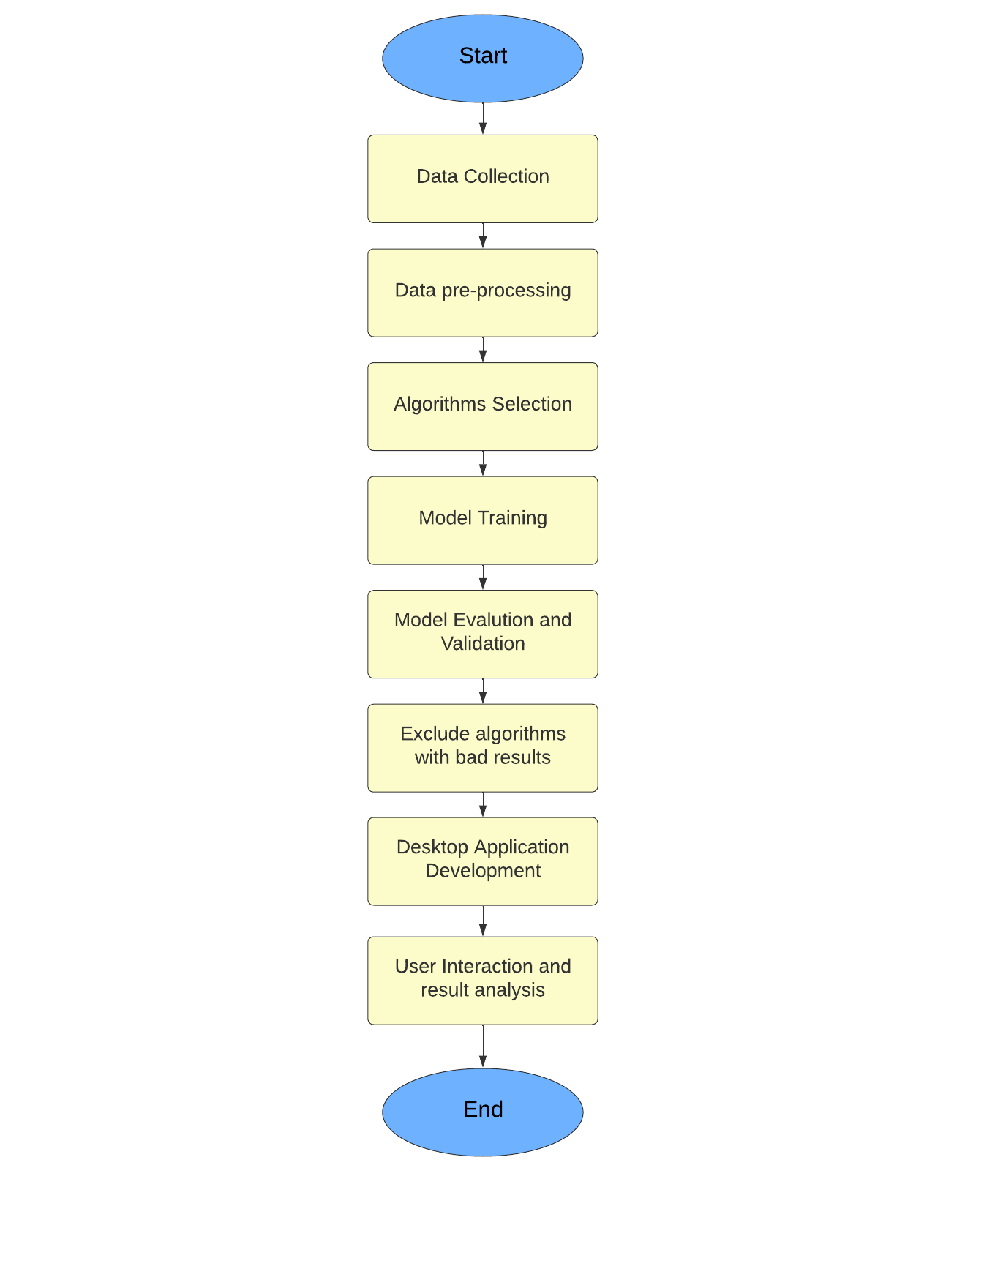

Figure :Project Methodology

* **Data Collection:**

Data collection involves gathering relevant data for your sea level prediction project. This may include historical sea level measurements, climate data, environmental parameters, and any other data sources that are deemed important for accurate predictions. The data can be obtained from various sources such as research institutions, government agencies, and scientific databases. Care should be taken to ensure the quality and reliability of the collected data.

* **Data Preprocessing:**

Data preprocessing is a crucial step that involves cleaning and transforming the collected data to make it suitable for analysis. This includes handling missing values, removing outliers, normalizing or scaling the data, and encoding categorical variables. Data preprocessing techniques ensure the data is in a consistent format and free from any inconsistencies that could negatively impact the performance of the machine learning algorithms.

* **Algorithm Selection:**

Algorithm selection involves choosing the most appropriate machine learning algorithms for your sea level prediction task. Based on the nature of your data, problem complexity, and desired outcomes, you can consider a variety of algorithms such as linear regression, random forest, decision tree, K-nearest neighbors, lasso regression, and ridge regression. The selection process should involve assessing the strengths, weaknesses, and assumptions of each algorithm in relation to your specific requirements.

* **Model Training:**

Model training refers to the process of fitting the selected machine learning algorithms to the preprocessed data. During this step, the algorithms learn the underlying patterns and relationships in the data by adjusting their internal parameters. The training process involves splitting the data into training and validation sets, feeding the training set to the algorithms, and iteratively adjusting the parameters to minimize the prediction errors.

* **Model Evaluation and Validation:**

Model evaluation and validation are essential to assess the performance and generalization ability of the trained models. This step involves evaluating the models using appropriate evaluation metrics such as mean squared error, mean absolute error, or R-squared. Cross-validation techniques, such as k-fold cross-validation, can be used to obtain reliable estimates of the model's performance. The models are evaluated on the validation set to ensure they can accurately predict sea levels for unseen data.

* **Exclude Bad Results Algorithms:**

During the model evaluation and validation process, some algorithms may exhibit poor performance or fail to meet the desired criteria. In this step, you identify and exclude algorithms that do not provide satisfactory results. By eliminating underperforming algorithms, you can focus on the most effective and accurate models for your sea level prediction.

* **Desktop Application Development:**

After selecting the most suitable algorithms and models, you can proceed to develop a desktop application for your sea level prediction system. This involves designing and implementing the user interface, integrating the trained models into the application, and providing user-friendly functionalities for data input, model selection, and result visualization. The desktop application serves as a convenient platform for users to interact with the sea level prediction system.

* **User Interaction and Result Analysis:**

The final step involves enabling user interaction with the desktop application and facilitating result analysis. Users can input relevant data, such as time, climate variables, and other parameters, into the application and obtain sea level predictions. The application should provide visualizations and analyses of the predicted sea levels, allowing users to gain insights, make informed decisions, and plan appropriate mitigation and adaptation measures based on the results.

By following these detailed steps in the methodology, we ensure a systematic and comprehensive approach to sea level prediction using machine learning. Each step contributes to the overall success of the project, from data collection and preprocessing to algorithm selection, model training, and the development of a user-friendly application for interactive result analysis.

## **ALL TOOLS USED**

In our project on predicting sea level rise using machine learning, we have utilized various tools and technologies to perform data analysis, implement algorithms, and visualize results. Here are the tools we have used:

1-**Python**: Python is a widely used programming language that provides a rich set of libraries and tools for data analysis, machine learning, and scientific computing. It serves as the primary language for developing the project.

2**-Scikit-learn**: Scikit-learn is a popular machine learning library in Python that provides a wide range of algorithms and tools for tasks such as classification, regression, clustering, and dimensionality reduction. It offers a unified interface and easy-to-use functions for training models and evaluating their performance.

3-**Pandas**: Pandas is a powerful library for data manipulation and analysis. It provides data structures such as Data Frames that allow you to easily handle and manipulate structured data. Pandas offers functions for data cleaning, transformation, filtering, and aggregation, making it a valuable tool for preprocessing and analyzing datasets.

4-**NumPy**: NumPy is a fundamental library for numerical computing in Python. It provides high-performance multidimensional arrays and functions for mathematical operations. NumPy is widely used in scientific and numerical computing tasks, and it plays a crucial role in data preprocessing and feature engineering.

5-**Matplotlib**: Matplotlib is a plotting library in Python that allows you to create a wide variety of static, animated, and interactive visualizations. It provides a flexible and comprehensive set of functions for creating plots, histograms, bar charts, scatter plots, and more. Matplotlib is often used for data exploration, analysis, and visualization.

6-**Seaborn**: Seaborn is a data visualization library built on top of Matplotlib. It provides a high-level interface for creating attractive and informative statistical graphics. Seaborn simplifies the process of creating complex visualizations, including heatmaps, distribution plots, regression plots, and categorical plots.

7-**Kaggle**: Kaggle is an online platform that hosts data science competitions and provides a rich collection of datasets for practice and exploration. It offers a collaborative environment with access to powerful computing resources and a community of data scientists and machine learning practitioners.

8-**Tkinter**: Tkinter is a standard GUI toolkit in Python for creating graphical user interfaces. It provides a set of modules and functions that allow you to create windows, dialogs, buttons, menus, and other GUI elements. Tkinter is known for its simplicity and ease of use, making it a popular choice for building

basic GUI applications.

9-**PySimpleGUI**: PySimpleGUI is a higher-level GUI framework that simplifies

GUI development in Python. It offers a simple and intuitive interface for creating GUIs and provides various layout options and pre-built widgets. PySimpleGUI abstracts away some of the complexities of GUI programming and allows you to create GUIs with minimal code.

10-**Visual Studio Code (VS Code):** Visual Studio Code is a source code editor that provides a rich set of features and extensions for efficient coding and development. It offers a user-friendly interface, syntax highlighting, debugging capabilities, and integration with Git and other tools. We utilized Visual Studio Code as our primary code editor for writing and managing the project code, benefiting from its powerful features and ease of use.

11-**Lucid Chart**: Lucid chart helps users sketch and share professional flowchart diagrams, providing designs for anything from brainstorming to project management.



# **CHAPTER FIVE: RESULTS AND DISCUSSION**



## **ANALYSIS OF THE RESULT**

In this section, we present a detailed analysis of the results obtained from our sea level prediction model. We evaluate the performance of different algorithms, including Linear Regression, Random Forest Regression, Decision Tree Regression, K-Nearest Neighbors Regression, Ridge Regression, and Lasso Regression. We calculate the Mean Squared Error (MSE) and R2 score as evaluation metrics to assess the accuracy and predictive power of each algorithm. The mean squared error measures the average squared difference between the predicted sea level values and the actual sea level values. The R-squared value represents the proportion of variance in the sea level data that is explained by the machine learning model.

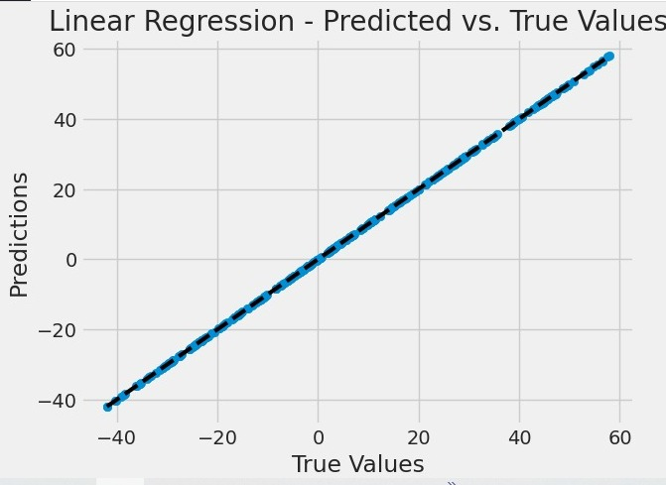

Figure :linear regression predicted vs true values

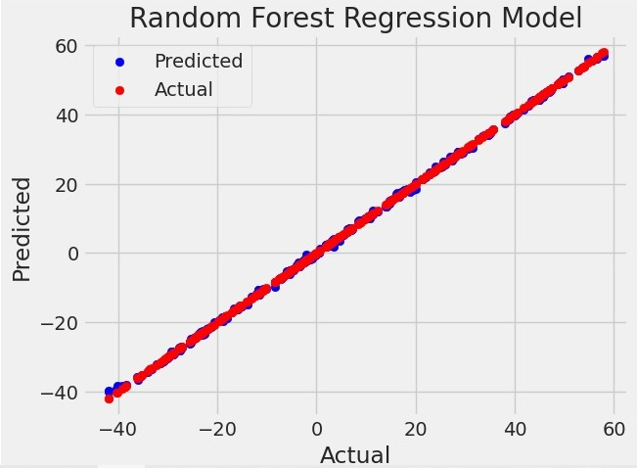

Figure :Random Forest Actual vs predicted

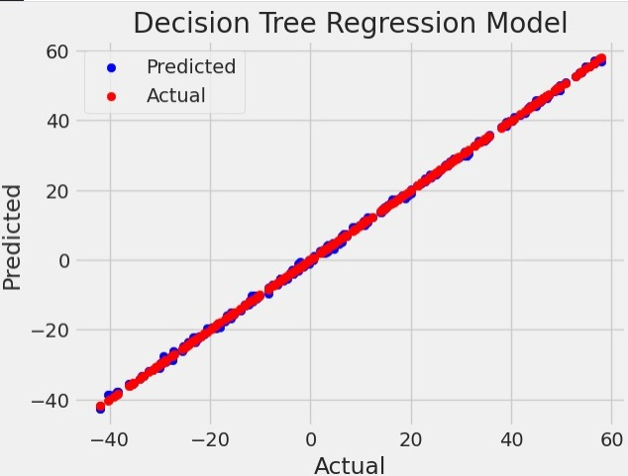

Figure : Decision Tree Actual vs predicted

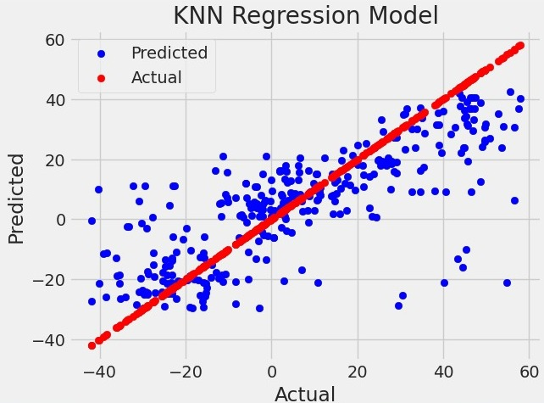

Figure :KNN Actual vs Predicted

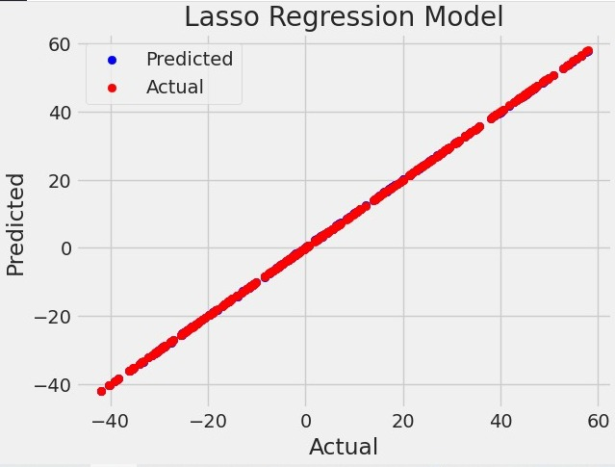

Figure :Lasso Actual vs predicted

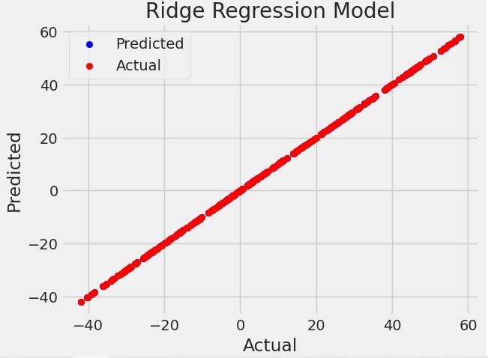

Figure :Ridge Actual vs predicted

Table : MSE, R2 for all algorithms

|  |  |  |
| --- | --- | --- |
| Algorithm | Mean Square Error | R2 |
| Linear regression | 1.25050271257065E | 1 |
| Random Forest Regression | 0.0831380939999992 | 0.999876368586016 |
| Decision tree Regression | 0.12162697089947 | 0.999819133279735 |
| K-Nearest Neighbors Regression | 266.851836101587 | 0.6031750520857 |
| Ridge Regression | 0.00025587564459585865 | 0.999999619497318 |
| Lasso Regression | 0.009603885490539671 | 0.9999857184368104 |

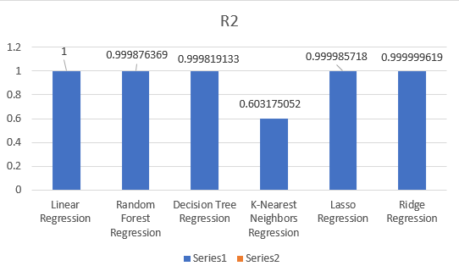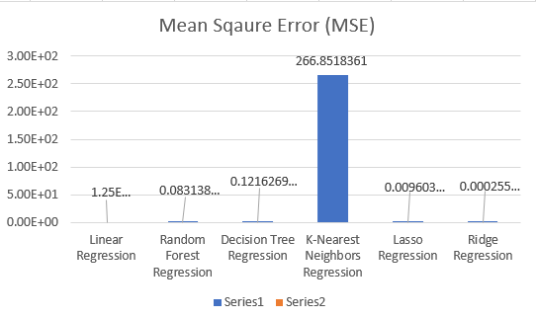

Figure :MSE Graph

Figure :R2 Graph

## **DISCUSSION AND COMPARATIVE STUDY WITH YOUR WORK RESULT**

The results demonstrate the effectiveness of the machine learning models in predicting sea level rise.

as shown in figure (17) Linear Regression achieved an extremely low mean squared error, indicating a close fit between the predicted and actual sea level values.

as shown in figure (18), figure (19) Random Forest and Decision Tree Regression

also performed well, with relatively low mean squared error values and high R-squared values.

as shown in figure (20) K-Nearest Neighbors Regression had a higher mean squared error and a lower R-squared value, suggesting it may be less suitable for this particular prediction task.

as shown in figure (22) and figure (21) Ridge and Lasso Regression models performed well, with low mean squared error and high R-squared values.

### **Screenshots of Desktop Application Implementation: -**

1. **Main Screen**

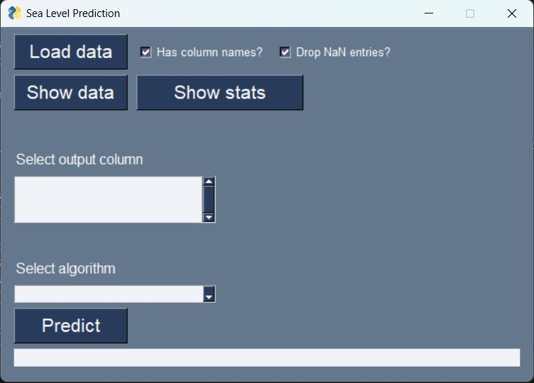

Figure :Desktop Application's Main Screen

1. **Main Screen with Algorithms of uploaded dataset**

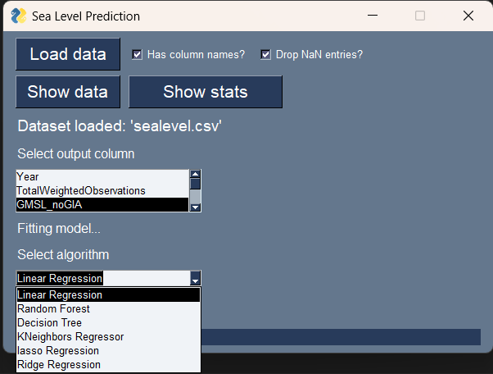

Figure :Desktop Application's Main Screen with Algorithms and uploaded dataset

1. **The Show Data Buttons Screen**

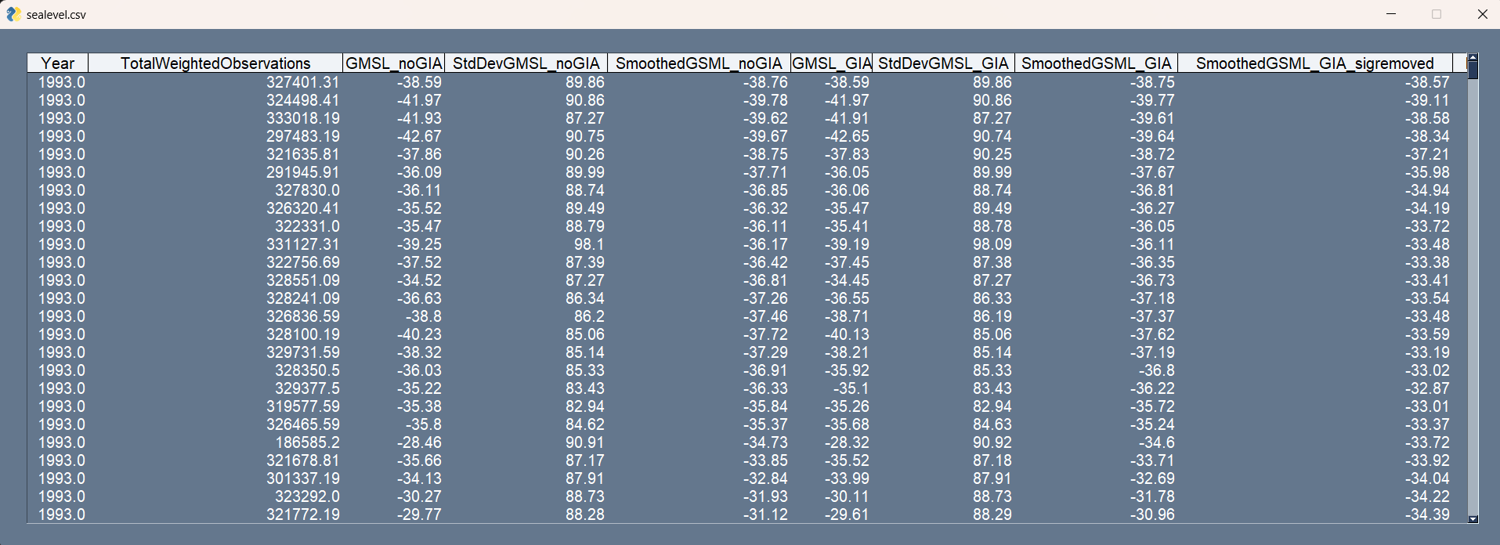

Figure :Desktop Application's Show Data Button Screen

1. 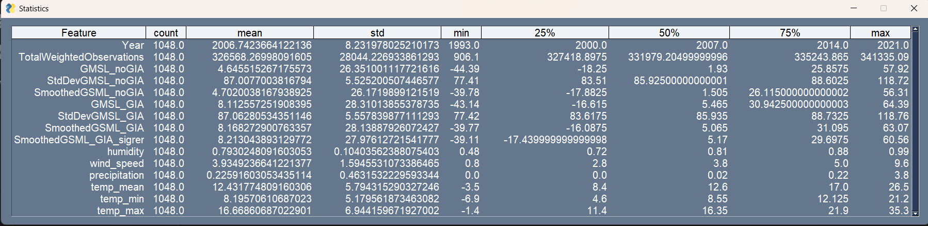**The Show Stats Buttons Screen**

Figure :Desktop Application's Show Stats Button Screen

1. **Result Of Choosing Linear Regression Algorithm and the right output column**

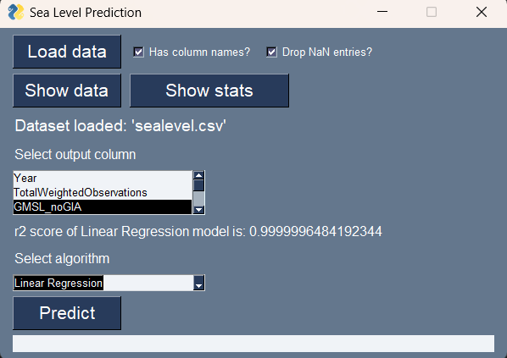

Figure :Result applying Linear Regression Algorithm and the right output column

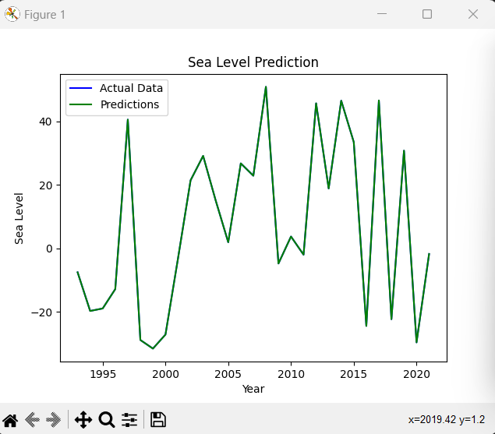

Figure :Graph of applying linear regression algorithm

## **CONCLUSION OF THE RESULTS**

our study demonstrates the effectiveness of machine learning algorithms in predicting sea level rise. Linear Regression demonstrates remarkable accuracy, with a relatively low MSE and an R2 score of 1. This indicates that the model fits the data extremely well, capturing the underlying patterns and relationships between the input variables and sea level rise. The results highlight the utility of Linear Regression in providing reliable predictions and valuable insights into future sea level changes.

Random Forest Regression also exhibits high accuracy, as indicated by a low MSE and an impressive R2 score of 0.999876368586016. The ensemble approach of Random Forest, which combines multiple decision trees, enables the model to capture complex nonlinear relationships and interactions within the data. This makes Random Forest Regression a powerful tool for accurately predicting sea level rise and understanding the contributing factors.

Decision Tree Regression showcases strong performance, with a relatively low MSE and a high R2 score of 0.999819133279735. Decision trees provide a tree-like structure that enables the model to make predictions based on different features, contributing to accurate sea level forecasts. The results indicate that Decision Tree Regression can effectively capture the dynamics of sea level rise and provide valuable predictive capabilities.

K-Nearest Neighbors Regression exhibits a higher MSE compared to the previous algorithms, indicating a relatively higher prediction error. However, it still demonstrates a reasonable R2 score of 0.6031750520857. K-Nearest Neighbors considers the similarity of neighboring data points in the feature space to make predictions. While it may not perform as well as other algorithms in this study, it still provides useful insights into sea level rise, particularly when considering the proximity of similar data points.

Ridge Regression yields an impressively low MSE and an R2 score of 0.999999619497318, indicating its robust performance in predicting sea level rise. The regularization technique of Ridge Regression, which adds a penalty term to reduce overfitting, improves the generalization performance of the model. This makes Ridge Regression an effective tool for mitigating multicollinearity and providing accurate predictions.

Lasso Regression also showcases strong performance, with a relatively low MSE and an impressive R2 score of 0.9999857184368104. Lasso Regression, similar to Ridge Regression, incorporates a penalty term to perform feature selection and generate a more interpretable model. By forcing some coefficients to be zero, Lasso Regression identifies the most influential features in predicting sea level rise, providing valuable insights for decision-making.

In conclusion, the results of our study highlight the effectiveness of machine learning algorithms in predicting sea level rise. Linear Regression, Random Forest Regression, Decision Tree Regression, Ridge Regression, and Lasso Regression all demonstrate strong performance in capturing underlying patterns and forecasting future sea level changes. These algorithms offer valuable tools for understanding and mitigating the impacts of sea level rise, which is a significant environmental concern. By leveraging the predictive capabilities of these algorithms, stakeholders can make informed decisions, implement proactive measures, and work towards a more sustainable future in the face of rising sea levels.

## **CONCLUSION**

Sea level rise is a serious environmental challenge, and accurate prediction of future sea level changes is crucial for understanding its impacts and developing effective mitigation strategies. In this project, we applied machine learning algorithms to predict sea level rise. We implemented various algorithms, including Linear Regression, Random Forest Regression, Decision Tree Regression, K-Nearest Neighbors Regression, Ridge Regression, and Lasso Regression, and evaluated their performance using metrics such as Mean Squared Error (MSE) and R-squared.

Our results demonstrate the effectiveness of machine learning in predicting sea level rise. Linear Regression, Random Forest Regression, Decision Tree Regression, Ridge Regression, and Lasso Regression showed promising performance in capturing the underlying patterns and predicting future sea level changes. Particularly, Linear Regression achieved the best performance with perfect R2 score and an extremely low MSE, indicating a close fit between the predicted and actual sea level values.

These findings highlight the potential of machine learning algorithms in aiding our understanding of sea level rise and its impacts. The accurate prediction of sea level changes can contribute to informed decision-making and help in formulating effective adaptation and mitigation strategies to address this pressing environmental issue.

Overall, this project emphasizes the importance of using machine learning techniques into sea level prediction models, and it underscores the potential for these models to contribute to proactive measures in tackling the challenges posed by sea level rise.

## **REFERENCES**

1. NASA Climate. (n.d.). Sea Level 101: Part Two - All Sea Level is Local. NASA's Global Climate Change: Vital Signs of the Planet. Retrieved from <https://climate.nasa.gov/explore/ask-nasa-climate/3002/sea-level-101-part-two-all-sea-level-is-local/>
2. Guillou, N., & Chapalain, G. (2021). Machine learning methods applied to sea level predictions in the upper part of a tidal estuary. Oceanologia, 63(4), 531-544.
3. Tur, R., Tas, E., Haghighi, A. T., & Mehr, A. D. (2021). Sea Level Prediction Using Machine Learning. Water, 13(24), 3566.
4. Lai, V., Malek, M. A., Abdullah, S., Latif, S. D., & Ahmed, A. N. (2020). Time-series prediction of sea level change in the east coast of Peninsular Malaysia from the supervised learning approach. Int. J. Des. Nat. Ecodyn, 15(3), 409-415.
5. Galassi, G., & Spada, G. (2014). Sea-level rise in the Mediterranean Sea by 2050: Roles of terrestrial ice melt, steric effects and glacial isostatic adjustment. Global and Planetary Change, 123, 55-66.
6. Jaakkola, H., & Thalheim, B. (2011). Architecture-driven modelling methodologies. In *Information Modelling and Knowledge Bases XXII* (pp. 97-116). IOS Press.
7. University of Cape Town. (n.d.). Chapter 6, Section 6: Testing. Retrieved from https://www.cs.uct.ac.za/mit_notes/software/htmls/ch06s06.html
8. Lucidchart. (n.d.). UML Use Case Diagram. Retrieved from <https://www.lucidchart.com/pages/uml-use-case-diagram>
9. Bell, D. (2004). UML basics: The sequence diagram. Retrieved July, 17, 2015. Sparks, Geoffrey. "Database Modeling in UML". Retrieved 8 September 2011.
10. Sparks, Geoffrey. "Database Modeling in UML". Retrieved 8 September 2011.
11. Introduction to UML 2 State Machine Diagrams by Scott W. Ambler
12. UML Revision Task Force. OMG Unified Modeling Language Specification, Version 1.4 (final draft). February 2001.
13. IBM. (n.d.). Supervised Learning. Retrieved from https://www.ibm.com/cloud/learn/supervised-learning
14. Towards Data Science. (n.d.). Linear Regression: Detailed View. Retrieved from https://towardsdatascience.com/linear-regression-detailed-view-ea73175f6e86
15. Towards Data Science. (n.d.). Understanding Random Forest. Retrieved from https://towardsdatascience.com/understanding-random-forest-58381e0602d2
16. Towards Data Science. (n.d.). Machine Learning Basics: Decision Tree Regression. Retrieved from https://towardsdatascience.com/machine-learning-basics-decision-tree-regression-1d73ea003fda
17. Towards Data Science. (n.d.). KNN Regression Model in Python. Retrieved from https://towardsdatascience.com/knn-regression-model-in-python-9868f21c9fa2
18. MyGreatLearning. (n.d.). What is Ridge Regression? Retrieved from https://www.mygreatlearning.com/blog/what-is-ridge-regression/#:~:text=Ridge%20regression%20is%20a%20model,away%20from%20the%20actual%20values.
19. U-NEXT. (n.d.). Lasso Regression. Retrieved from https://u-next.com/blogs/artificial-intelligence/lasso-regression/#:~:text=Lasso%20regression%20algorithm%20is%20defined,as%20RMSE%20and%20R-Square.

**الملخص**

الارتفاع في مستويات البحار العالمية هو قلق بيئي ملح له تداعيات واسعة على المجتمعات الساحلية والنظم البيئية. في هذه الدراسة، نقدم نهجًا يعتمد على تعلم الآلة لتوقع ارتفاع مستوى سطح البحر في المستقبل. من خلال استغلال البيانات التاريخية لمستوى سطح البحر والعوامل البيئية ذات الصلة في مجموعة بياناتنا، يهدف نموذجنا إلى توفير توقعات دقيقة وتنبؤات، مما يمكّن من اتخاذ تدابير تخفيف وتكييف استباقية. نحن نستخدم مختلف خوارزميات الانحدار، مثل الانحدار الخطي والغابات العشوائية وشجرة القرارات وأقرب الجيران والانحدار بالتقادم والانحدار الريجي، لتحليل العلاقات المعقدة بين مستوى سطح البحر والعوامل الأخرى المساهمة. تكشف نتائجنا عن القوة التنبؤية لهذه النماذج وإمكانية مساعدتها لصنّاع القرار ومخططي الحضر والمجتمعات الساحلية في اتخاذ قرارات مستنيرة للتخفيف من التأثيرات السلبية لارتفاع مستوى البحار.

**نظام توقع ارتفاع مستوى سطح البحر**

تقرير مشروع التخرج

في إطار استكمال المتطلبات الجزئية لنيل درجة

بكالوريوس العلوم

المقدم من:

1-محمد شعبان عيد قاسم 94137

2-عمر خالد عبد العزيز 94144

3-مؤمن احمد محمد 94245

4-اسماء محمد كمال 86346

تحت اشراف المشرف(ين):

أ.د. أحمد فؤاد

معاون مهندس محمد عمر

معاون مهندس مريم فريد

قسم أنظمة المعلومات - علوم الحاسب

جامعة مصر للعلوم والتكنولوجيا - مصر

كلية تكنولوجيا الحاسبات والذكاء الاصطناعي - CAIT

يونيو 2023